Adwaita Elements Problems (as I see them)

1. GTK3 buttons and certain other items are still inconsistent with GTK2
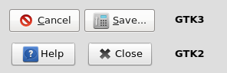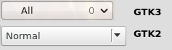

2. GTK3 tabs have poor text spacing and should be larger and darker

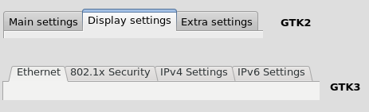

3. GTK3 menu lists are smaller than GTK2 ones
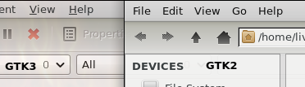

4. Firefox has white text when a menu entry is selected
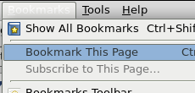

5. pavucontrol has inconsistent background colours between items


